**VISVESVARAYA TECHNOLOGICAL UNIVERSITY**

**“JnanaSangama”, Belgaum -590014, Karnataka.**



**LAB REPORT**

**on**

**COURSE TITLE**

***Submitted by***

**Shashwat Khanna(1BM19CS148)**

***in partial fulfillment for the award of the degree of***

**BACHELOR OF ENGINEERING**

***in***

**COMPUTER SCIENCE AND ENGINEERING**



**B.M.S. COLLEGE OF ENGINEERING**

**(Autonomous Institution under VTU)**

**BENGALURU-560019**

**May-2022 to July-2022**

**B. M. S. College of Engineering,**

**Bull Temple Road, Bangalore 560019**

(Affiliated To Visvesvaraya Technological University, Belgaum)

**Department of Computer Science and Engineering**



**CERTIFICATE**

This is to certify that the Lab work entitled “**Object Oriented Modelling and Design**” carried out by **Shashwat Khanna (1BM19CS148),** who is bonafide student of **B. M. S. College of Engineering.** It is in partial fulfillment for the award of **Bachelor of Engineering in Computer Science and Engineering** of the Visvesvaraya Technological University, Belgaum during the year 2022. The Lab report has been approved as it satisfies the academic requirements in respect of a **Object Oriented Modelling and Design - (20CS6PCOMD)** work prescribed for the said degree.

Latha NR                **Dr. Jyothi S Nayak**

Professor Professor and Head

Department of CSE Department of CSE

BMSCE, Bengaluru BMSCE, Bengaluru

**Index Sheet**

| **Sl. No.** | **Experiment Title** | **Page No.** |
| --- | --- | --- |
| **1** | **COLLEGE MANAGEMENT SYSTEM** |  |
| **2** | **HOSTEL MANAGEMENT SYSTEM** |  |
| **3** | **STOCK MAINTENANCE SYSTEM** |  |
| **4** | **COFFEE VENDING MACHINE** |  |
| **5** | **ONLINE SHOPPING SYSTEM** |  |
| **6** | **RAILWAY RESERVATION SYSTEM** |  |
| **7** | **GRAPHICS EDITOR SYSTEM** |  |
|  |  |  |
|  |  |  |
|  |  |  |
|  |  |  |
|  |  |  |
|  |  |  |
|  |  |  |
|  |  |  |

**Course Outcome**

|  |  |
| --- | --- |

**1.College Management System**

* 1. **Problem statement**

The College Information System is a system that maintains student,staff and department information . It maintains the courses taught by teachers and students enrolled in them. Admission records of student and Examination details and other important information related to college management is maintained.

* 1. **Software Requirement Specification**
* College information system has admin who manages the staff ,student and department.
* Admin can view and modify the student’s records like student’s profile, attendance, fee, results, and details of teachers and other employees in college, their personal information and their attendance for their salaries.
* In this system, user authentication will be done by login by user name and password and classified by user type.
* Staff in college teach more than one course to many students and the staff who are teachers conduct examinations for students of the college
* The students of the college register themselves in the department and for the courses they are interested in and join the college by taking admission and following all the admission procedures.
* There are different types of examination conducted by the college for the students. Internals and semester end examination are two of them.
* Every course has a name and its unique name. Every course has different subjects and every subject has its own unique name.
* Department will provide the details about departments within a college with their name and every department have its Department name.

Class Diagram:

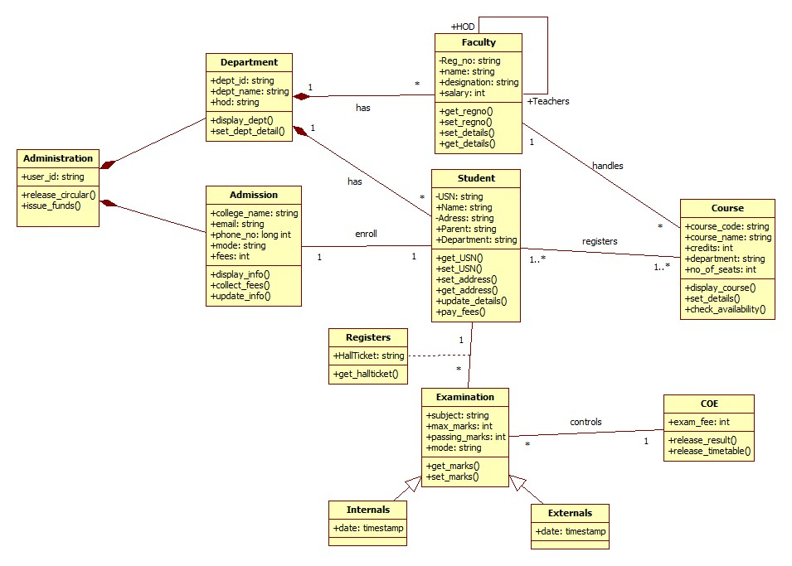

State Diagram:

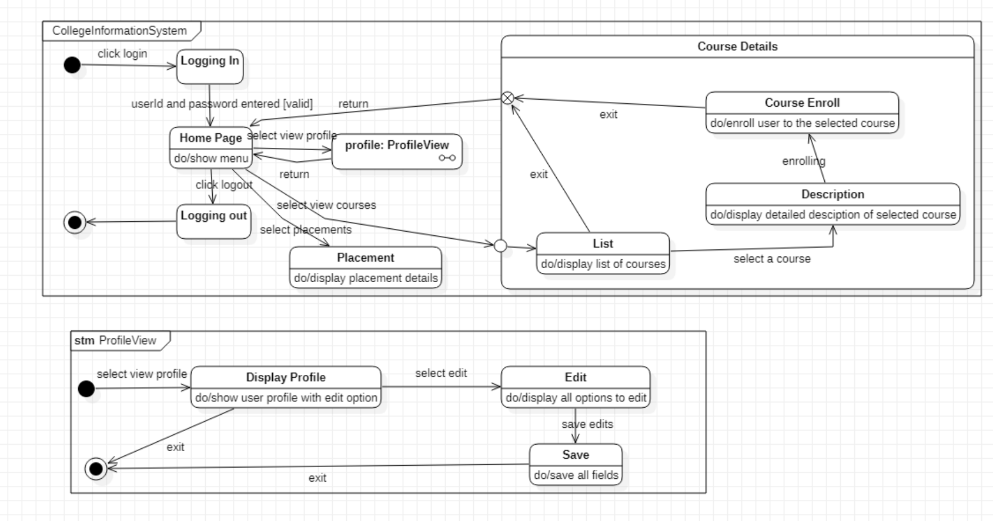

**2.Hostel Management System**

* 1. **Problem statement**

The hostel management system is to provide college students accommodation to the university hostel more efficiently. This project also keeps details of the hostelers and applied students. It is headed by Warden. He will be the administrator.This document is intended to minimize human works and make hostel allocation an easier job for students and hostel authorities by providing online application for hostel.

* 1. **Software Requirement Specification**
* Hostel management system has admin who manages the hostel,allot-es and payment methods.The admin will allocate a room to student according to the section or class. The admin will also keep track of the payment made by the student/allot-es .
* As the student’s course is over they will vacate their rooms. So it is required for the administrator to remove their records from the database tables.
* The allot-es makes payment according to the bill generated which have the attributes bill number,type and date.
* The details of the students staying in the hostels like name, place, address, contact details is maintained in the database.
* The hostel is categorized into two types I.e boys and girls hostel.Each hostel type has different costs ,warden and name.
* A hostel is made up of mess and rooms.A mess account will also generate. This account having the mess status of the whole month. On the base of this account monthly charges of mess of a student will be defined.
* The hostel management system will allow renewing the student’s registration every year.the rooms of hostel are composed of table and beds,where a count of the same is maintained and the allot-es can use them as they wish.

Class Diagram: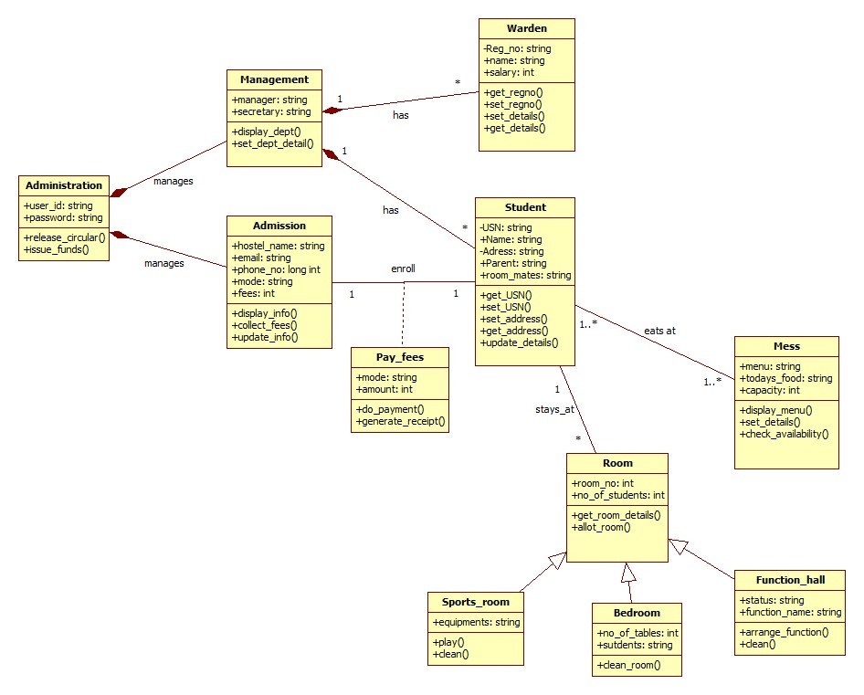

State Diagram: 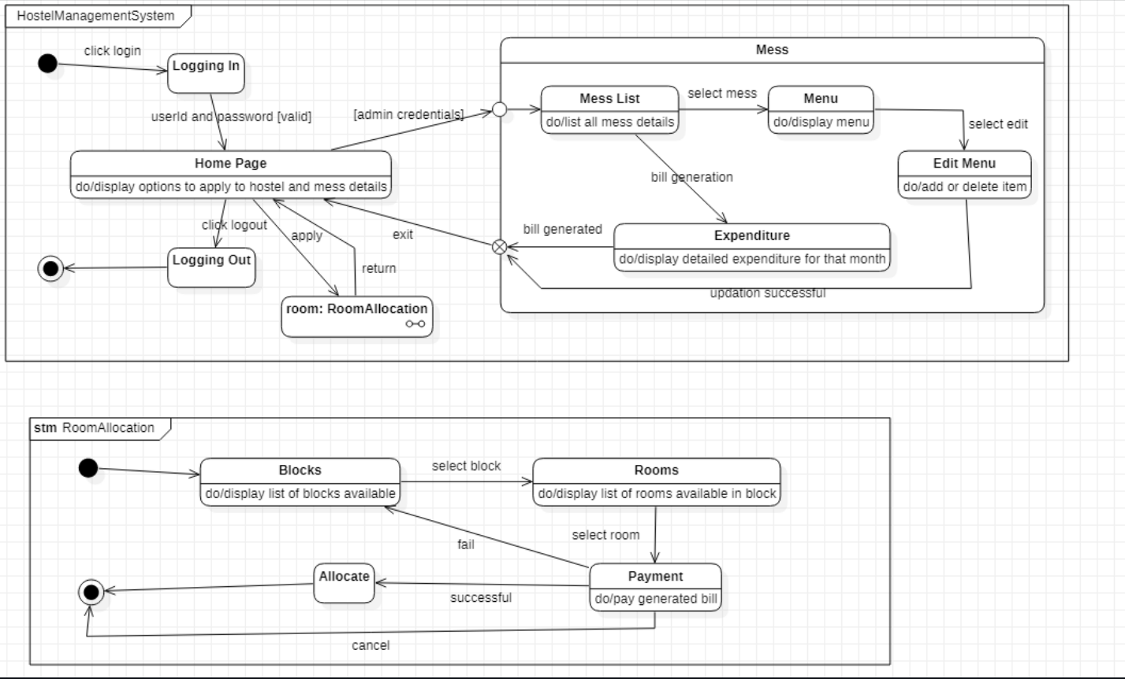

**3.Stock Maintenance System**

* 1. **Problem statement**

The stock maintenance system is basically for the customers who access the information about the stock and retrieves the information.The stock maintenance system is to replace the existing maintenance system which is in efficient. The new stock maintenance system will allow the employee to record information of the products available in the store .The vendor deals with the information about the details of the suppliers giving product to the organization.

* 1. **Software Requirement Specification**
* The customer can purchase one or more product on any day,which will have a code price and quantity.
* The customer will need to pay the bill for the products he or she has purchased.the bill number,type description and customer who is paying the bill is maintained.
* The stock of the products is maintained separately,The stock deals with information about the details of the product that the concern handling.
* Stock consist of details such as the name of the product, id generated, quantity, cost, etc. This information is retrieved during the sales and purchase of a product.
* The vendor deals with the information about the details of the suppliers giving product to the organization.
* Vendor consist of details such as vendor name, address, email id, sales tax number etc. This information is retrieved when a Purchase is done
* The products are displayed in stores across the city or world. All the information regarding the store such as store id,name,address and type are used to locate any product.The stores can be of many types.Some of them are departmental stores,super markets and ware houses where the products are kept for display.

Class Diagram: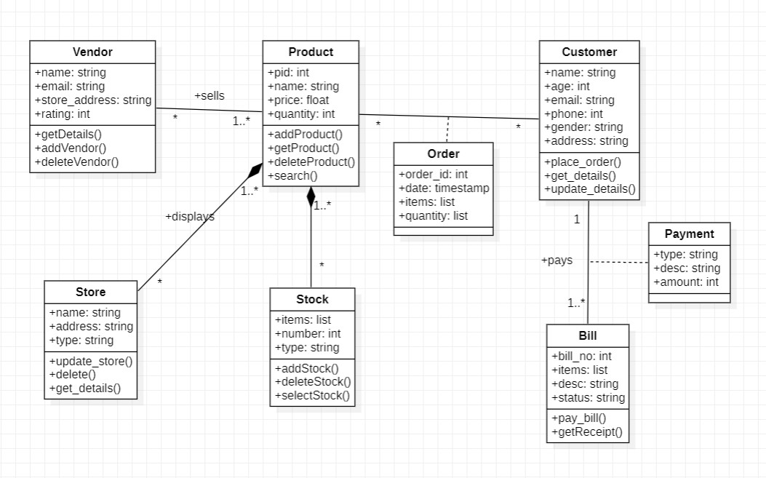

State Diagram: 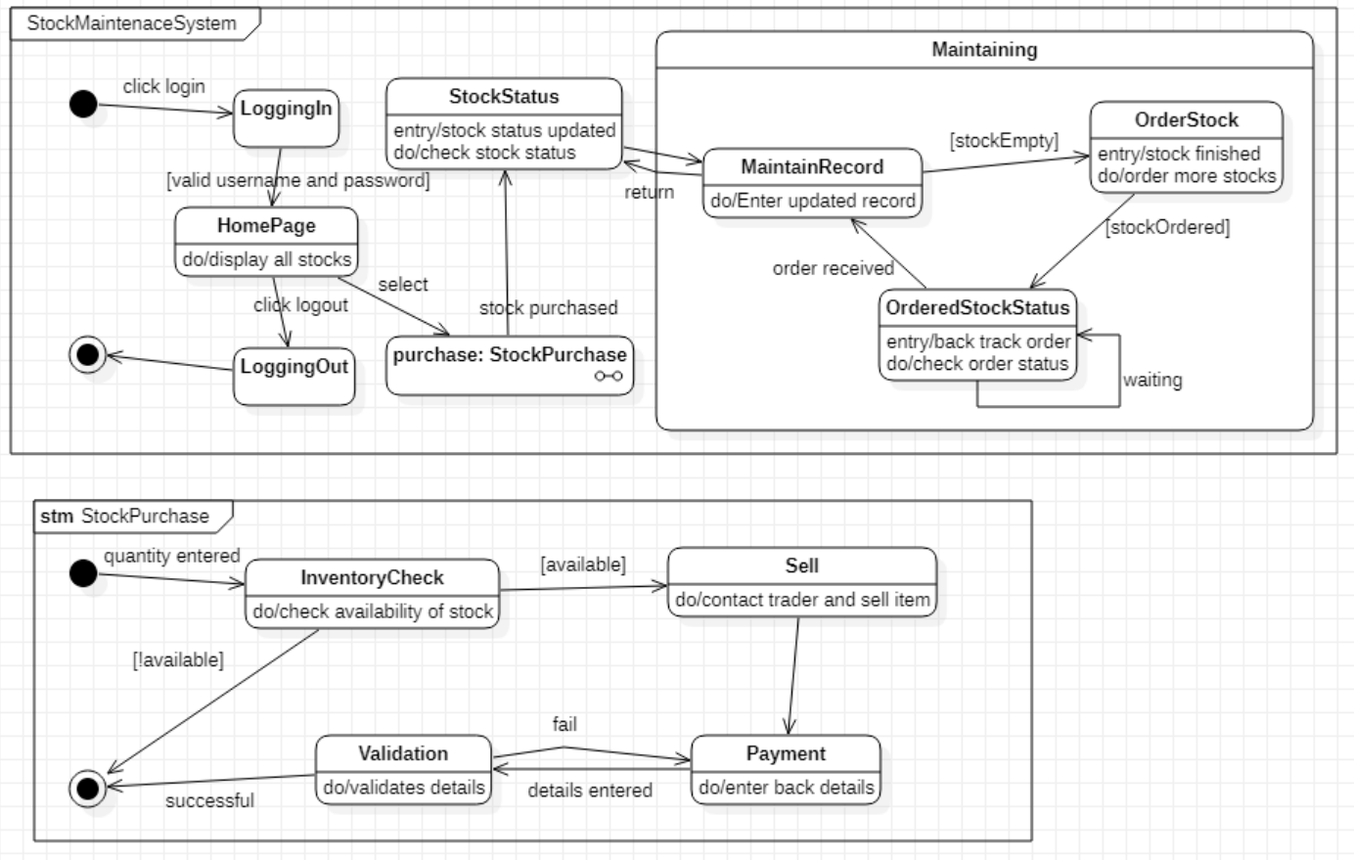

**4.Coffee Vending Machine**

* 1. **Problem statement**

The coffee vending machine is basically for the customers to buy coffee by themselves without any third person being involved. A coffee vending machine sells different types of coffee such as cappuccino,black coffee,cold coffee and latte. Each type of coffee has a price and a name. A customer can buy their choice of coffee by selecting the button of their coffee and paying for the same through the coin box.

* 1. **Software Requirement Specification**
* The vending machine must have money box, coin slot, display screen and products i.e coffee for the machine to be used.
* The user on selecting a coffee ,the coffee machine must be able to dispense the selected coffee to the user.
* The user shall get empty cup placed right below the filter.The user shall be able to choose his preferred beverage from the list of options(buttons).
* There must be buttons(start,pause,stop,coffee,tea,milk) for user to interact with the system.
* The user shall be able to purchase one kind of available drink at a time and get back the exact changes if he has put extra money. The user shall be able to quit the dispense of any beverage at any time during the dispensing.
* The system(machine) shall check for properly inserted coins.
* The system shall be able to dispense coffee(or selected beverage) after a coin has been inserted.
* The system must accept coins of different amount and the system must compare the item cost with entered coin.
* The system must check the validity of coins.
* The system shall be able to detect the low amount of ingredients and low number of cups and indicate with an indicator(small LED).

Class Diagram: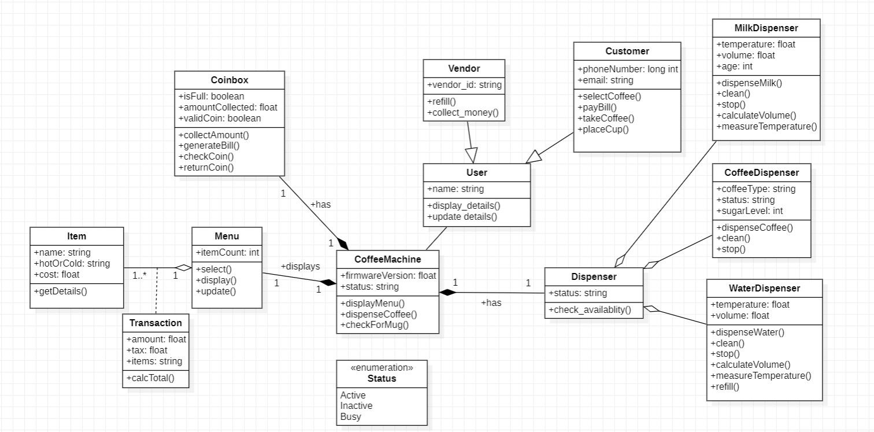

State Diagram: 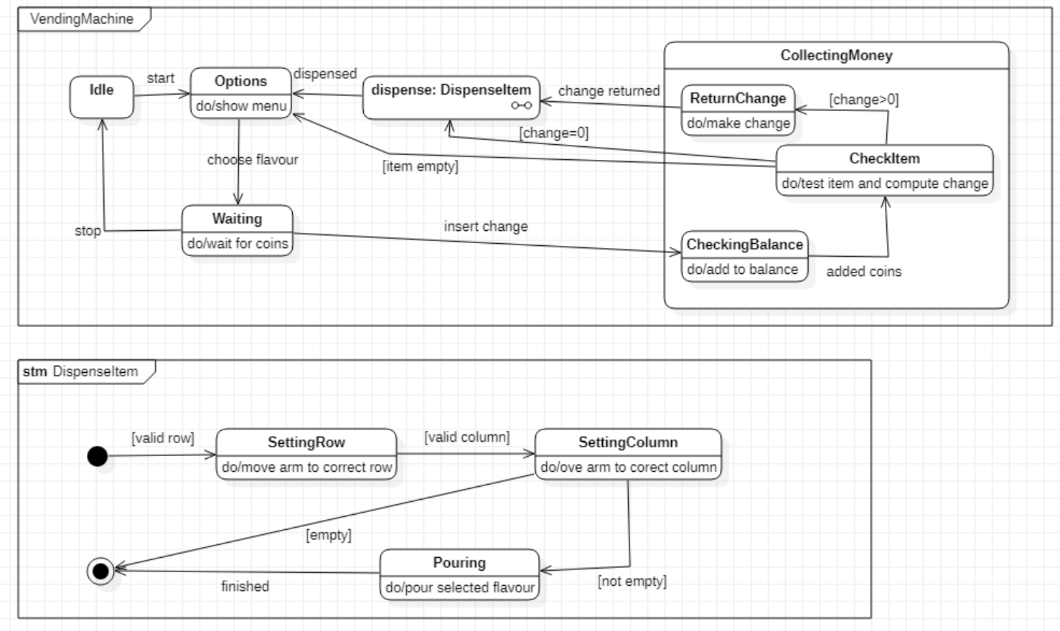

**5.Online Shopping System**

* 1. **Problem statement**

The Online Shopping System for all kind of products web application is intended to provide complete solutions for vendors as well as customers through a single get way using the internet. It will enable vendors to setup online shops, customer to browse through the shop and purchase them online without having to visit the shop physically. The administration module will enable a system administrator to approve and reject requests for new shops and maintain various lists of shop category.This system allows the customer’s to maintain their cart for add or remove the product over the internet.

* 1. **Software Requirement Specification**
* The customer must have an account in the online website where he/she can purchase products.
* If customer wants to buy the product then he/she must be registered, unregistered user can’t go to the shopping cart.
* Customer login to the system by entering valid user id and password for the shopping.
* Changes to cart means the customer after login or registration can make order or cancel order of the product from the shopping cart.
* The products sold for customers are sold for various categories like men,women,kids and home products.
* Customers can view all available products ,compare them and make a choice for purchasing the products.
* For customer there are many type of secure billing will be prepaid as debit or credit card, post paid as after shipping, check or bank draft. The security will provide by the third party like Pay-Pal etc.
* After the payment or surf the product the customer will logged out.

Class Diagram: 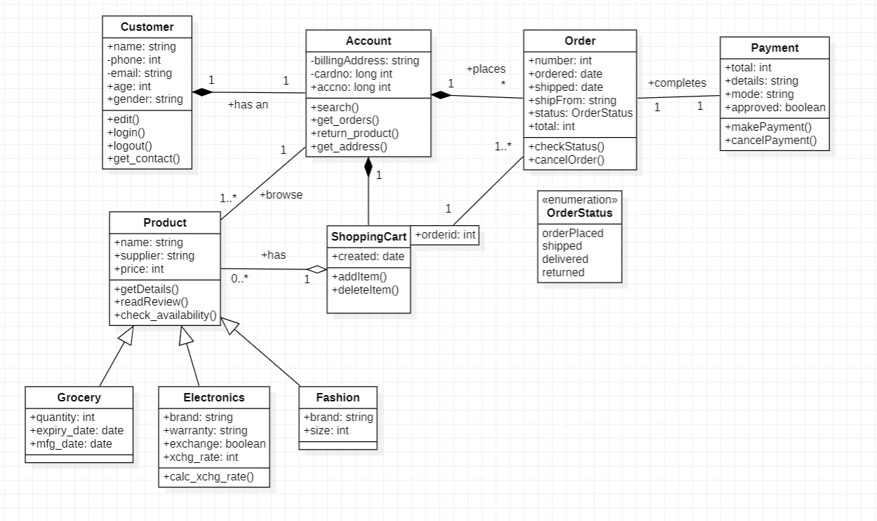

State Diagram: 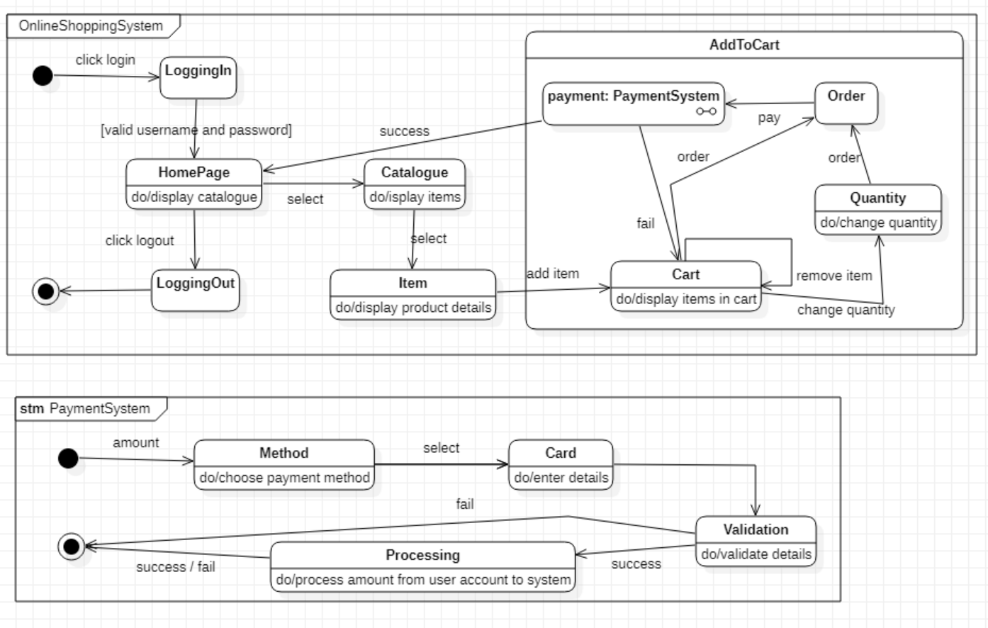

**6.Railway Reservation System**

* 1. **Problem statement**

Railway Reservation System is a system used for booking tickets over internet.Any Customer Can book tickets for different trains.Software has to be developed for automating the manual reservation system of railway.The system should be standalone in nature.It should be designed to provide functionalists like booking of tickets in which a user should be able to applied for tickets of any train and of any class.The software takes the current system date and time as the date of issue and calculates the amount to be paid by the user. It also provide the functionality of cancellation of tickets.

* 1. **Software Requirement Specification**
* Each user should have a user id and a password.Record of the users of the system should be kept in the log file. Provision should be made for full backup of the system.
* The customers can view the trains available at any day,the cost and number of tickets available for any train.
* Customer can book a ticket only if the tickets are available.Customer searches for the availability of tickets then if the tickets are available he books the tickets by initially filling details in a form.
* Tickets can be booked in two ways by i-ticket or by e-ticket booking.
* In case of i-ticket booking customer can book the tickets online and the tickets are couriered to Particular customer at their address.But in case of e-ticket booking and canceling tickets are booked and canceled online sitting at the home and customer himself has to take print of the ticket but in both the cases amount for tickets are deducted from customers account.
* For cancellation of ticket the customer has to go at reservation office than fill cancellation form and ask the clerk to cancel the ticket than the refund is transferred to customer account.
* After booking ticket the customer has to checkout by paying fare amount to clerk.
* The system displays the details of train of which user enter the name.The information is saved and the corresponding updating take place in the database.

Class Diagram: 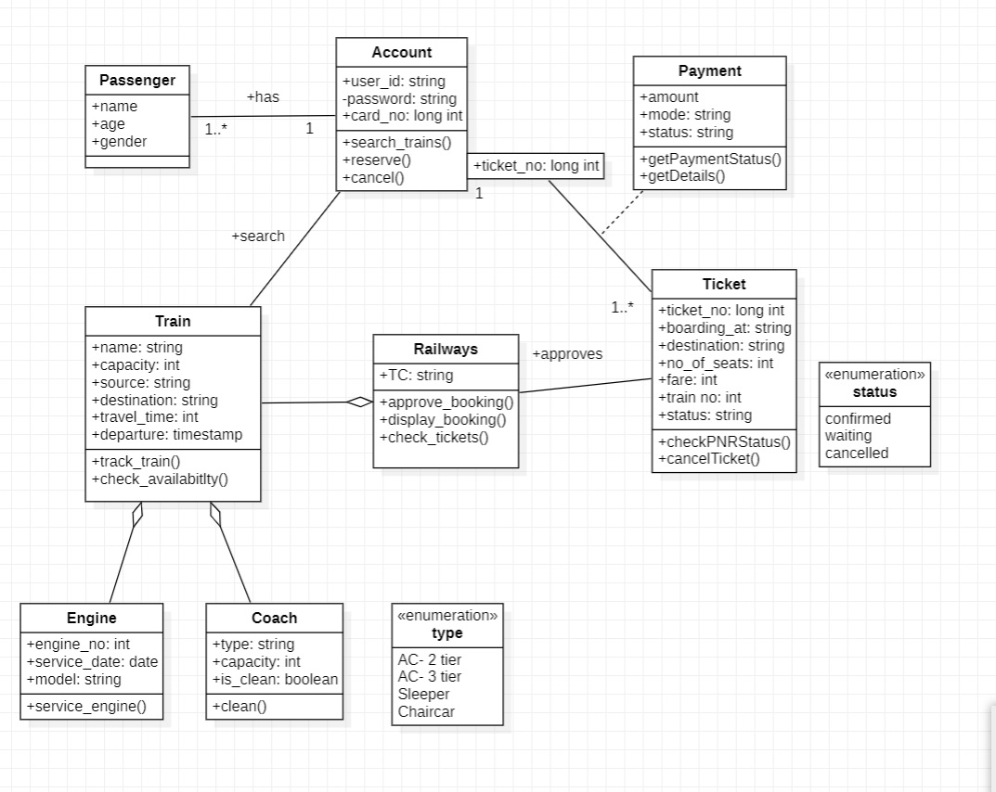

State Diagram: 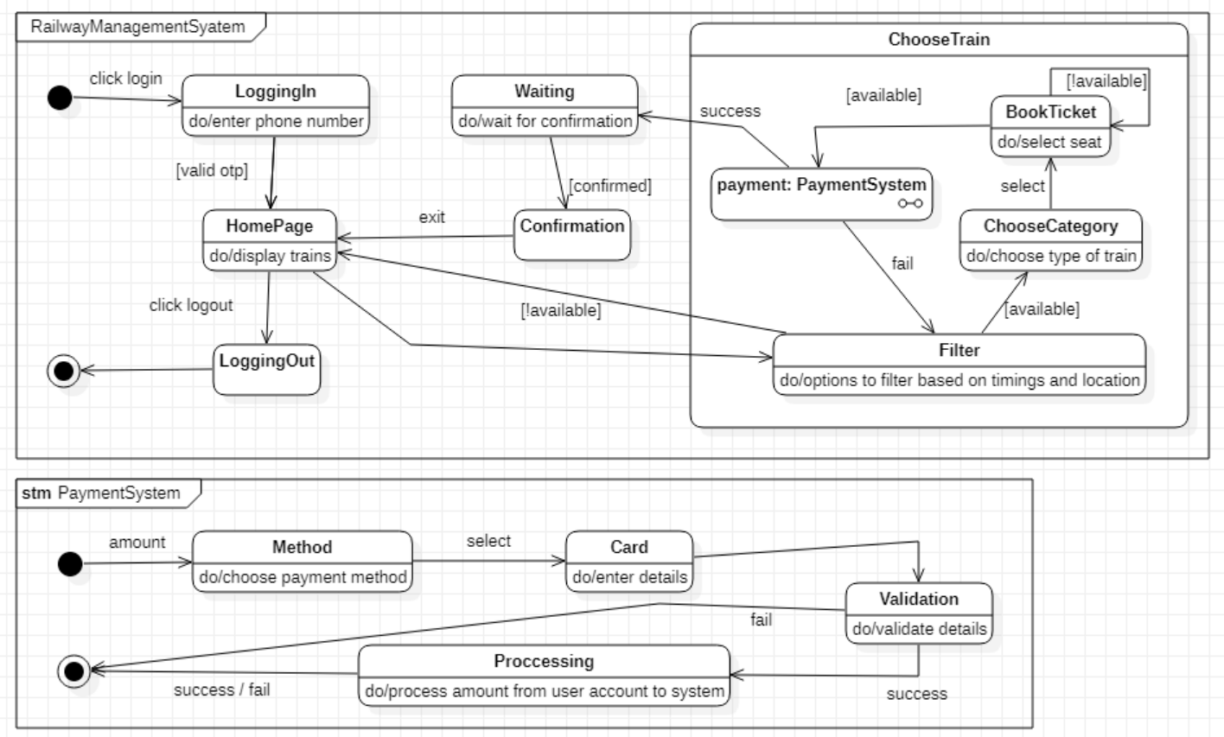

**7.Graphics Editor System**

* 1. **Problem statement**

The graphics editor provides an Application Programmer’s Interface that enables a programmer to develop their own graphical model editor for a specific type of model. This API in turn, relies on extending the Eclipse Graphical Editing Framework to provide an environment in which the editor functions, and the programmer can create a graphical editor and palette of shapes in order to modify an underlying model.the graphical editor provides an interface with which the programmer implements said editor for a given underlying model. Such instance of the graphical editor allows a user to drag objects from a specified model into a working graphical diagram.

* 1. **Software Requirement Specification**
* The graphical editor consists of a graphical document editor which can be used to create new document,delete document,update or view the document.
* The graphical document editor consists of many documents,where each document can be saved,opened,printed or create a new one
* A document is made up of many sheets which can have graphics included in them.
* Sheets have multiple number of drawing objects,which can be created, grouped or formatted.
* The programmer must provide implementations of functions that draw objects and their connections, as well as functions that add and remove connections. The latter function will be handled by a specific event listener. Any changes made in real-time to the underlying model will also be updated in the diagram through a separate event listener
* The user can also add and remove connections between these objects as needed using the palette supplied, thus modifying the underlying model.
* Each sheet contains drawing objects, including text, geometrical objects and groups.A group is simply a set of drawing objects.
* A geometrical object includes circle, ellipse, rectangles, lines and squares,trapeziums which are identified by their respective constraints.

Class Diagram: 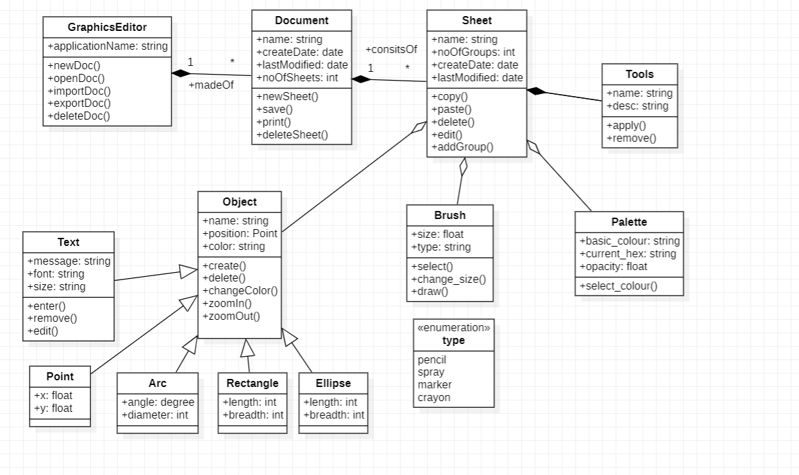

State Diagram: 